Date: 31/01/2018

University/Academic Institution: Sandip University Course Name: M.Tech ACDS
Batch Name: 2017-19 Module Name: Advanced Data Structures

Pre -Assignment: (All programs to be committed via git only)

1. Declare a 1 – Dimensional array in C++ and find the smallest and largest value in the array.
ANS:
CODE:

#include<iostream>
using namespace std;

int main()
{
int Arr[100],n,i,small,large;

cout<<"Enter number of elements you want to insert ";
cin>>n;

for(i=0;i<n;i++)
{
cout<<"Enter element "<<i+1<<":";
cin>>Arr[i];
}

small=Arr[0];
large=Arr[0];

for(i=1;i<n;i++)
{
if(Arr[i]<small)
small=Arr[i];
if(Arr[i]>large)
large=Arr[i];
}

cout<<"\nLargest element is :"<<large;
cout<<"\nSmallest element is :"<<small;

return 0;
}

OUTPUT:
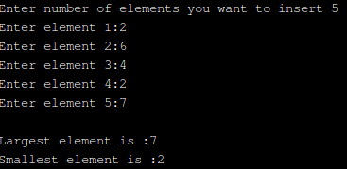

2. Write a program in C++ finds the length of the string and also displays the string reverse, compare two strings to check whether they are equal or not and concatenate two strings, convert string to lower case/upper case.

ANS:

CODE 1:
#include<iostream>
#include<conio.h>
#include<string.h>
#include<stdio.h>
using namespace std;

int main()
{
clrscr();
char str[20], i, j, temp;
cout<<"Enter a string : ";
gets(str);
int len=strlen(str);
cout<<"Length of the string is "<<len<<"\n";
j=strlen(str)-1;
while(i<j)
{
temp=str[i];
str[i]=str[j];
str[j]=temp;
i++;
j--;
}
cout<<"Reverse of the String = "<<str;

getch();
return 0;
}

OUTPUT 1:

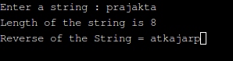

CODE 2:

#include<iostream>
#include<conio.h>
#include<string.h>
#include<stdio.h>
using namespace std;

int main()
{
clrscr();
char str1[20], str2[20], i, j;
int len;
cout<<"Enter a string1 : ";
cin>>str1;
cout<<"Enter a string2 : ";
cin>>str2;

//length of both strings

len=strlen(str1);
cout<<"Length of the string is "<<len<<"\n";
j=strlen(str1)-1;

len=strlen(str2);
cout<<"Length of the string is "<<len<<"\n";
j=strlen(str2)-1;

//compare both strings

if(strcmp(str1, str2)==0)
{
cout<<"Both the strings are equal"<<"\n";
}
else
{
cout<<"Both the strings are not equal"<<"\n";
}

//concat both strings

strcat(str1, str2);
cout<<"String after concatenation is "<<str1<<"\n";

//uppercase string 1

for(i=0;i<=strlen(str1);i++)
{
if(str1[i]>=97 && str1[i]<=122)
{
str1[i]=str1[i]-32;
}
}
cout<<"\nThe String in Uppercase = "<<str1;

getch();
return 0;
}

OUTPUT 2:

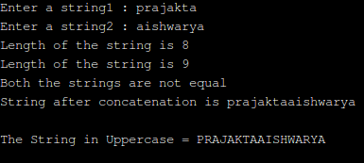

3. Write a menu driven C++ program to do following operation on two dimensional array B of size a x b. You should use user-defined functions which accept 2-D array A and its size a and b as arguments. The options are:

To input elements into matrix of size a x b
To display elements of matrix of size a x b

ANS:

CODE:

#include<iostream>
using namespace std;

int main()
{
//MATRIX A

int matA[2][2]; // matrix can have max 2rows and 2 cols
int i, j;
cout << "Enter the matrix elements row-wise :- " << endl;
for ( i = 0; i < 2; i++ )
{ // outer loop iterates over each row
for ( j = 0; j < 2; j++ )
{ // inter loop iterates over each column
cout << "matA[" << i << "][" << j << "] : ";
// i -> row no. and j -> col no.
cin >> matA[i][j];
}
}
// display the matrix
cout << "You have entered the matrix :- " << endl;
for ( i = 0; i < 2; i++ )
{
for ( j = 0; j < 2; j++ )
{
cout << matA[i][j] << " ";
}
cout << endl;
}

// MATRIX B

int matB[2][2]; // matrix can have max 2 rows and 2 cols

cout << "Enter the matrix elements row-wise :- " << endl;
for ( i = 0; i < 2; i++ )
{ // outer loop iterates over each row
for ( j = 0; j < 2; j++ )
{ // inter loop iterates over each column
cout << "matB[" << i << "][" << j << "] : ";
// i -> row no. and j -> col no.
cin >> matB[i][j];
}
}
// display the matrix
cout << "You have entered the matrix :- " << endl;
for ( i = 0; i < 2; i++ )
{
for ( j = 0; j < 2; j++ )
{
cout << matB[i][j] << " ";
}
cout << endl;
}
return 0;
}

OUTPUT:
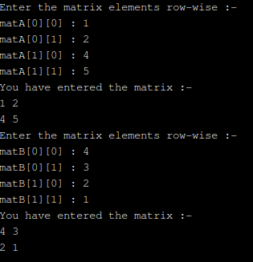

4. An array stores details of 10 students (rollno, name, marks in three subject). Write a program to create such an array and print out a list of students who have failed in more than one subject.

ANS:

CODE:

#include<iostream>
#include<conio.h>
using namespace std;

struct stud
{
int roll;
char nm[50];
float m1, m2, m3;
};

typedef stud S;

int main()
{
S student[10];
int i;

for(i =0 ; i < 10 ; i++)
{
cout << "\n Enter Roll no : ";
cin >> student[i].roll;

cout << "\n Enter Name : ";
cin >> student[i].nm, 50;

cout << "\n Enter marks of three subjects :";
cin >> student[i].m1 >> student[i].m2 >> student[i].m3 ;

}

cout<< "\n STUDENTS FAILED IN MORE THAN 1 SUBJECT \n ";
for(i =0 ; i < 10 ; i++)
{
if(( student[i].m1< 40 && student[i].m2 < 40) || (student[i].m2 < 40 && student[i].m3 < 40) || ( student[i].m1 < 40 && student[i].m3 < 40))
cout << student[i].roll << "\t" << student[i].nm << "\n";
}

getch();

}

OUTPUT:

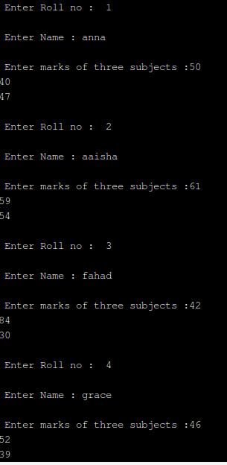

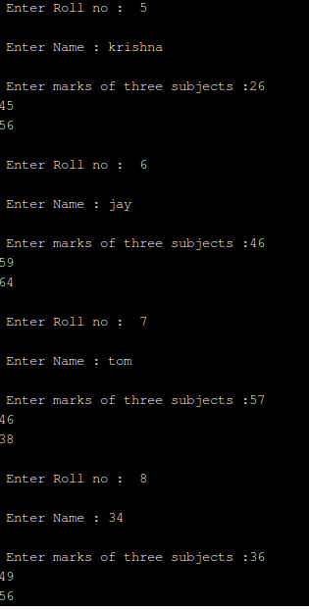

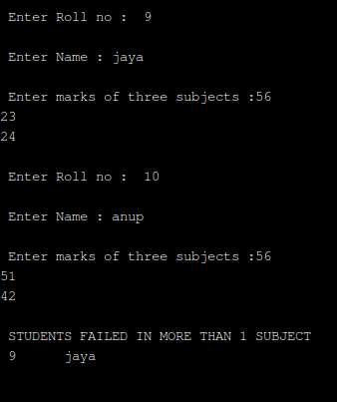

Pre –Seminar Topics

Seminar Date = 02/02/2018

Timing - 10:00 am

170847980001 | Control Statements in C++ (With Programs)
170847980002 | OOPS Concepts in C++ (Only Polymorphism)
170847980003 | Strings in C++ (With Programs)
170847980004 | Pointer in C++ (Just Basics ppt)
170847980005 | Algorithm (Time and Space Complexity) (Basic ppt)
170847980007 | Functions (User Defined and Built-in Functions with Programs)
170847980008 | Classes and Objects in C++ (With Programs)
170847980009 | Arrays in C++ (With Programs)
170847980010 | Stack and Queue (Basic ppt)
170847980011 | OOPS Concepts in C++ (Only Inheritance)
170847980012 | Structures in C++ (With

